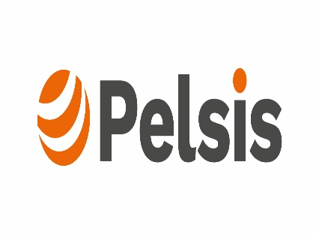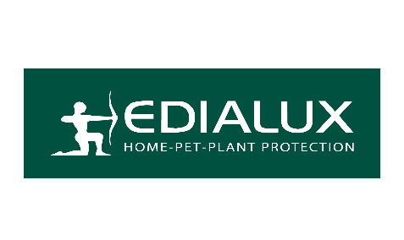
_________________________________________________________________________________

Press Release
Date : 18 March 2026
Section: Home & Garden

The PELSIS Group, a world leader in pest control with a presence in 80 countries and 15 production sites, invites you to get a preview of its two comprehensive product ranges for the French consumer market, covering various distribution channels:

- EDIALUX : A well-established brand since 1975, it caters to specialists by offering them a wide range of products that meet high standards in terms of performance and environmental friendliness.
This range is distributed by: VILMORIN JARDIN: Stand N - 41 Hall 2

- PORTLAND GARDEN : The brand, which is celebrating its 80th anniversary, is aimed at food market and offers products covering the main needs for home and garden, whilst meeting today’s consumer expectations.
This range is distributed by: SANRIVAL JARDIN: Stand P - 62 Hall 2

The ranges include, in particular:
- Biocontrol slug killer, including the 3% ultra-concentrate – a market-leading product – Suitable for use in Organic Farming* and Ecocert**

- The Special Fruits & Vegetable Biocontrol Fungicide, based on microorganisms, Suitable for use in Organic Farming* and Ecocert**

- Biocontrol weedkillers, based on pelargonic acid

__________________________________________________________________________________

- Cleaning products, such as Black Soap, made from olive oil, or Enzimo, made from enzymes

- PT18 biocides: insecticides for ants, crawling and flying insects, available as sprays and powders, based on pyrethrum or geraniol

- And PT19, Repellents and Attractants, made from sweet orange extract, lemon eucalyptus oil or other traditional ingredients, and registered at European level, for use against mosquitoes, wasps, flies, etc.

- Pheromone or sticky traps against moths, cockroaches, silverfish, bedbugs, etc., containing no insecticide

- Slug barriers or physical traps for mice and rats, to meet the demand from consumers seeking natural solutions.

And many more… Come and discover them STAND N – 77 Hall 2


Press contact: Sophie Gori, International Coordinator Marketing & Regulatory Marketing:
sophie.gori@pelsis.com / 06.75.01.66.67
Commercial contact: Julian Amieva, Commercial Director France : julian.amieva@pelsis.com / 07.44.94.90.50

In accordance with current EC regulations
Control ECOCERT SAS
Use plant protection products and biocides safely. Before use, read the label and the product information.

