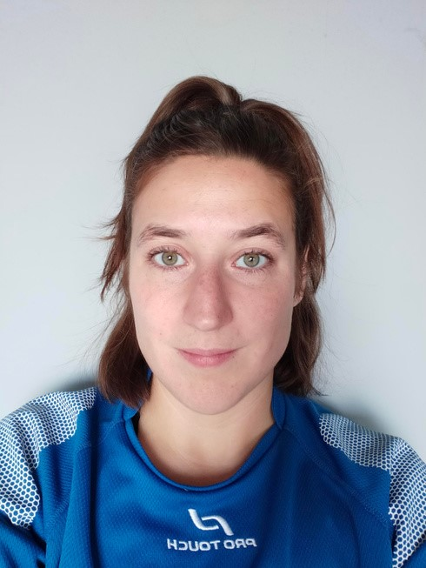


Contact
Education
06.20.77.77.99
Phone
jade.boucard@hotmail.fr
Email
rue du docteur Sureau
70
Noisy-le-Grand
93160
Address
Jade Boucard
A
T
L
O
-

E
v
e
n
t

m
a
n
a
g
e
r

a
s
s
i
s
t
a
n
t
Experiences

support for sports teams (in English), check the run sheet's stages
-
management and coordination of technical teams, operations office
-
development/attribution of endowments + accreditation cards to volunteer teams and
-
officials (partners/media)
18
set up and management of the solidarity mission (team of 7 scouts between 16 and
-
years old) in French and in English
Sales consultant (French and English)
Head mission

11
/18,
19/2022
2019 - 2021
July-August 2019
In Extenso Supersevens, Accor Arena la Défense
GR Events, Champs Elysées (PARIS)
Solidarity Scout Mission, Kolkata (INDIA)
(
U6-U
8)
French Literature and culture
FEDERAL DIPLOMA

HIGH SCHOOL DIPLOMA (2010)
2021-2022
DRIVING LICENCE
FLUENT ENGLISH
(1
year in New-York / 2 months in
Oxford/ 2 months in Kolkata)
BASIC SPANISH
)
(1
month in Barcelona
Languages
Training
2017
01/22/2023
Paris Basket, Accor Arena Bercy (PARIS)
ensure optimal conditions for the running of the competition
-
communication between Campus 2023 apprentices and volunteers team's head
-
July 2018-July 2019
Mamaroneck/Manhattan (NEW-YORK)
Au Pair
-
development of intercultural skills
English civilization studies
-
2015-2018
Vincennes (FRANCE)
-
supervise and support students during their studies (570 students
)
-
meet the needs of different audiences (students, parents, teachers
)
planning
-
and
organizing
the
Baccalaureate
exams,
ensure
the
follow-up
of
security
protocols + internal regulations
2010-2015
Val d'Europe (FRANCE)
Education Personnel
Luxury jewerly sales consultant
References available upon request
-
link and communication between the team, the staff, hotel personnel, the city of Montpellier
and France 2023.
e
-
nsuring compliance with the contracts between the team, France 2023, and World Rugby.
m
-
anagement of the schedule, travel, and delivery of matches in coordination with the GIGN
team

and France 2023.
).
escort driving (players, staff, guests...
-
-
link and communication between the team, the staff, hotel personnel, Nice and Paris
2024.
2024).
ensuring compliance with the specifications (commitments of the team and Paris
-
management of the team's schedule, community services, travel, delivery of matches (escort
-
driving, staff, and players).
ensure the team’s exit plan.
-
Liaison officer, Samoa team

FRANCE 2023
RUGBY WORLD CUP 2023
OLYMPIC GAMES, PARIS 2024
Liaison officer, Zambia football team
Town Hall of Neuilly-Plaisance : Coordinator Child and Youth Services
-
in charge of educational and pedagogical projects
November 2023 - March 2025 (until the 7th)
Administrator licenses responsible for
sports facilities and in charge of sports
event management
CAMPUS 2023 (2021-2023)

