Fluorescent probes for the study of the epithelial cell cytosqueleton and the safety of cosmetic ingredients

Marion Gay¹, Abdelkhalek Ben Jamaa¹, Françoise Bree³, Christiane Guguen-Guillouzo³, Pierre Daligaux^{3*}, Christophe Chesné³, Karen Plé¹, Sylvain Routier^{1*}
¹ Institut de Chimie Organique et Analytique, Université d’Orléans, CNRS 7311, Orléans, France
³ Starlight, 111 Boulevard Duhamel de Monceau, Olivet, France
*Corresponding author e-mail: p.daligaux@wepredic.com, sylvain.routier@univ-orleans.fr
The cosmetic industry is facing new challenges to select and use ingredients with confidence. To ensure consumer safety this means being able to evaluate both their effectiveness and reliability. Our project combines chemistry and cell biology to design and validate fluorescent probes to evaluate the toxicity of cosmetic ingredients, alone or incorporated in a formulation.
The goal of our project is to transpose a validated process developed in experimental pharmacology to the specific problems of the cosmetic industry. We have designed probes to target specific cell signaling pathways whose respective roles are to activate or deactivate cytoskeletal movement affecting cell plasticity. This was done in order to visualize their function in the presence of external chemical agents including formulation components.
We have used the HepaRGTM cell line as a representative model of the shape and contraction of bile canaliculi in hepatocytes. This is an excellent model of epithelial cells, including skin keratinocytes. The cells were treated with various molecules known to induce cholestasis, a pathology which modifies the hepatocyte cytoskeleton, such as Chlorpromazine (CPZ), Fasudil (FAS) and Cyclosporine A (CSA).
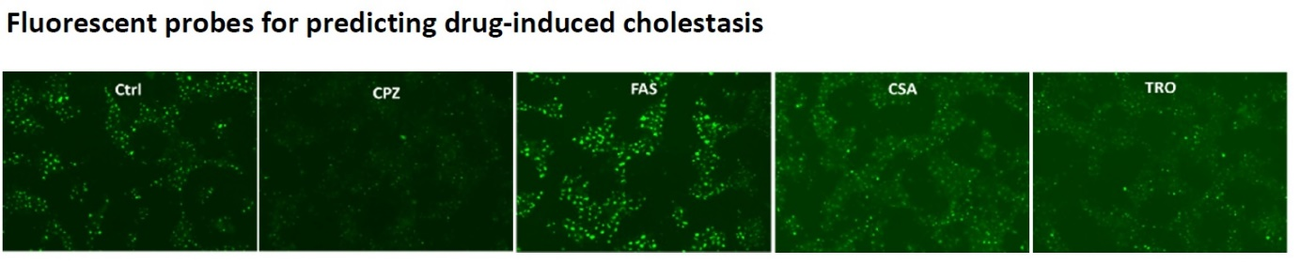
2D-differentiated HepaRG cells (HPR116 from Biopredic) were incubated with 5µM FluobileTM probe at 37°C for 30 min. After washing, cells were incubated with reference cholestatic compounds (CPZ: Chlorpromazine, FAS: Fasudil, CSA: Cyclosporine A, TRO: Troglitazone).
Our FluobileTM probes accumulate in bile canaliculi and thus allow the visualization of bile acid transport. The rapid detection of cellular bile accumulation and the easy evaluation of the constriction/dilation state of the bile canaliculi allow them to be used to predict the potential toxicity of chemical compounds including cosmetic ingredients.
The authors would like to thank the Région Centre Val de Loire and Cosmetosciences Program for their financial support and Cosmetic Valley for their certification of this research project.
(1) Vinken, M.; Pauwels, M.; Ates, G.; Vivier, M.; Vanhaecke, T.; Rogiers, V. Screening of Repeated Dose Toxicity Data Present in SCC(NF)P/SCCS Safety Evaluations of Cosmetic Ingredients. Arch. Toxicol. 2012, 86 (3), 405–412. https://doi.org/10.1007/s00204-011-0769-z.

